**Building a Smarter AI-Powered Spam Classifier**

Team member

621421104501-Arunkumar.S

**Phase 2 project submission**

**Project title:** AI Powered Spam Classifier

**Introduction:**

Humans master millions of words, but computationally speaking: how can we manipulate large amounts of text using programming techniques?

The idea that computers can understand ordinary languages and hold conversations with human beings has been a staple of science fiction. However, the first half of the twentieth century and was envisaged in a classic paper by Alan Turing (1950) as a hallmark of computational intelligence.

This article will focus on how computer systems can analyze and interpret texts, using the Natural Language Processing (NLP). For that, you should install Natural Language Toolkit, you can do it from http://nltk.org. Instructions are available on the cited website along with details of associated packages that need to be installed as well, including Python itself, which is also freely available.

What is Natural Language Processing (NLP) ?

Natural Language processing or NLP is a subset of Artificial Intelligence (AI), where it is basically responsible for the understanding of human language by a machine or a robot.

One of the important subtopics in NLP is Natural Language Understanding (NLU) and the reason is that it is used to understand the structure and meaning of human language, and then with the help of computer science transform this linguistic knowledge into algorithms of Rules-based machine learning that can solve specific problems and perform desired tasks.

**LANGUAGE PROCCESS IN PYTHON:**

The purpose of this article is to show you how to detect spam in SMS.

For that, we use a dataset from the UCI datasets, which is a public set that contain SMS labelled messages that have been collected for mobile phone spam research. It has one collection composed by 5.574 SMS phone messages in English, tagged according being legitimate (ham) or spam.

Therefore, we will train a model to learn to automatically discriminate between ham / spam. Then we will use “test data” to test the model. Finally to evaluate if our model is efficient, we will calculate Accuracy, Classification report and Confusion Matrix.

Exploratory Data Analysis

To get started, we should first imports all the library, then load the data and rename names columns:

# Import library

import pandas as pd

import numpy as np

* import string

import seaborn as sns

import matplotlib.pyplot as plt

from nltk.corpus import stopwords

from sklearn.feature_extraction.text import CountVectorizer

from sklearn.feature_extraction.text import TfidfTransformer

from sklearn.model_selection import train_test_split

from sklearn.svm import SVC

from collections import Counter

from sklearn.metrics import classification_report,confusion_matrix

from sklearn.model_selection import GridSearchCV

%matplotlib inline

# Load data

data = pd.read_excel('data.xlsx')

# Rename names columns

data.columns = ['label', 'messages']

Let’s see a description of our data:

data.describe()

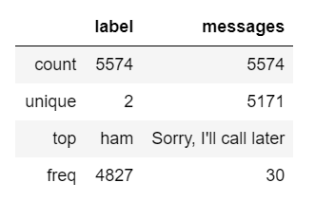

Data Description (Image by Author)

Note that our data contains a collection of 5574 SMS and also we have only 2 label: ham and spam. Now, we create a column called ‘length’ to know how long the text messages are and then plot it against the label:

data["length"] = data["messages"].apply(len)

data.sort_values(by='length', ascending=False).head(10)

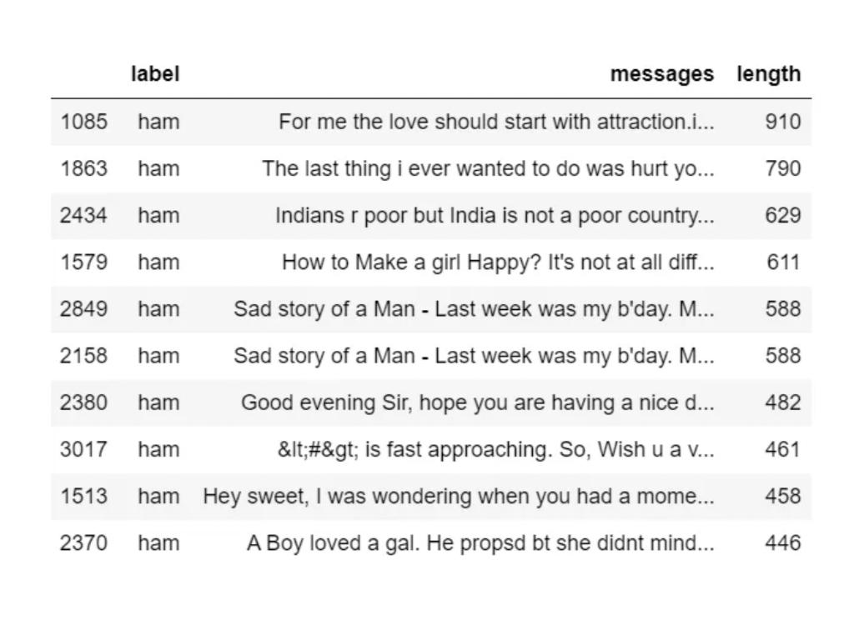

data.hist(column = 'length', by ='label',figsize=(12,4), bins = 5)

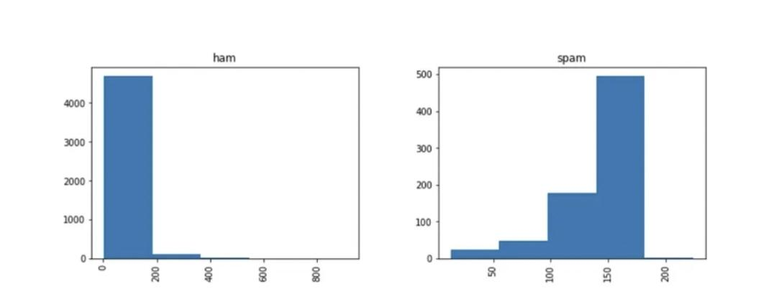

Histogram between lenght and label (Image by Author)

Note that through the histogram, we have been able to discover that spam messages tend to have more characters.

Most likely, most of the data you have come across is numeric or categorical, but what happens when it is of type string (text format)?

As you may have noticed, our data is of type string. Therefore, we should transform it into a numeric vector to be able to perform the classification task. To do this, we use bag-of-words where each unique word in a text will be represented by a number. However, before doing this transformation, we should remove all punctuations and then common words like: [‘I’, ‘my’, ‘myself’, ‘we’, ‘our’, ‘our’ , ‘ourselves’, ‘you’, ‘are’ …]. This process is called tokenization. After this process, we convert our string sequence into number sequences.

Remove all punctuation: Suppose we have the following sentence:

**********Hi everyone!!! it is a pleasure to meet you.**********

and we want to remove !!! and .

First, we load the import string library and do the following:

message = "Hi everyone!!! it is a pleasure to meet you."

message_not_punc = []

for punctuation in message:

if punctuation not in string.punctuation:

message_not_punc.append(punctuation)

# Join the characters again to form the string.

message_not_punc = ''.join(message_not_punc)

print(message_not_punc)

>>> Hi everyone it is a pleasure to meet you

2. Remove common words:

To do that, we use the library nltk, i.e, from nltk.corpus import stopwords

Is important to know that stopwords have 23 languages supported by it (this number must be up to date). In this case, we use English language:

from nltk.corpus import stopwords

# Remove any stopwords for remove_punc, but first we should to transform this into the list.

message_clean = list(message_not_punc.split(" "))

# Remove any stopwords

i = 0

while i <= len(message_clean):

for mess in message_clean:

if mess.lower() in stopwords.words(‘english’):

message_clean.remove(mess)

i =i +1

print(message_clean)

>>> ['Hi', 'everyone', 'pleasure', 'meet']

Thus, with the steps 1 and 2, we can create the following function:

en in app

Sign up

Sign In

How to identify Spam using Natural Language Processing (NLP)?

Email Spam Detection using Natural Language Processing with Python

Patrizia Castagno

Towards Data Science

Patrizia Castagno

·

Follow

Published in

Towards Data Science

8 min read

·

Oct 26, 2020

Listen

Share

Humans master millions of words, but computationally speaking: how can we manipulate large amounts of text using programming techniques?

The idea that computers can understand ordinary languages and hold conversations with human beings has been a staple of science fiction. However, the first half of the twentieth century and was envisaged in a classic paper by Alan Turing (1950) as a hallmark of computational intelligence.

This article will focus on how computer systems can analyze and interpret texts, using the Natural Language Processing (NLP). For that, you should install Natural Language Toolkit, you can do it from http://nltk.org. Instructions are available on the cited website along with details of associated packages that need to be installed as well, including Python itself, which is also freely available.

What is Natural Language Processing (NLP) ?

Natural Language processing or NLP is a subset of Artificial Intelligence (AI), where it is basically responsible for the understanding of human language by a machine or a robot.

One of the important subtopics in NLP is Natural Language Understanding (NLU) and the reason is that it is used to understand the structure and meaning of human language, and then with the help of computer science transform this linguistic knowledge into algorithms of Rules-based machine learning that can solve specific problems and perform desired tasks.

LANGUAGE PROCCESS IN PYTHON

The purpose of this article is to show you how to detect spam in SMS.

For that, we use a dataset from the UCI datasets, which is a public set that contain SMS labelled messages that have been collected for mobile phone spam research. It has one collection composed by 5.574 SMS phone messages in English, tagged according being legitimate (ham) or spam.

Therefore, we will train a model to learn to automatically discriminate between ham / spam. Then we will use “test data” to test the model. Finally to evaluate if our model is efficient, we will calculate Accuracy, Classification report and Confusion Matrix.

Exploratory Data Analysis

To get started, we should first imports all the library, then load the data and rename names columns:

# Import library

import pandas as pd

import numpy as np

import string

import seaborn as sns

import matplotlib.pyplot as plt

from nltk.corpus import stopwords

from sklearn.feature_extraction.text import CountVectorizer

from sklearn.feature_extraction.text import TfidfTransformer

from sklearn.model_selection import train_test_split

from sklearn.svm import SVC

from collections import Counter

from sklearn.metrics import classification_report,confusion_matrix

from sklearn.model_selection import GridSearchCV

%matplotlib inline

# Load data

data = pd.read_excel('data.xlsx')

# Rename names columns

data.columns = ['label', 'messages']

Let’s see a description of our data:

data.describe()

Data Description (Image by Author)

Note that our data contains a collection of 5574 SMS and also we have only 2 label: ham and spam. Now, we create a column called ‘length’ to know how long the text messages are and then plot it against the label:

data["length"] = data["messages"].apply(len)

data.sort_values(by='length', ascending=False).head(10)

data.hist(column = 'length', by ='label',figsize=(12,4), bins = 5)

Histogram between lenght and label (Image by Author)

Note that through the histogram, we have been able to discover that spam messages tend to have more characters.

Most likely, most of the data you have come across is numeric or categorical, but what happens when it is of type string (text format)?

As you may have noticed, our data is of type string. Therefore, we should transform it into a numeric vector to be able to perform the classification task. To do this, we use bag-of-words where each unique word in a text will be represented by a number. However, before doing this transformation, we should remove all punctuations and then common words like: [‘I’, ‘my’, ‘myself’, ‘we’, ‘our’, ‘our’ , ‘ourselves’, ‘you’, ‘are’ …]. This process is called tokenization. After this process, we convert our string sequence into number sequences.

Remove all punctuation: Suppose we have the following sentence:

**********Hi everyone!!! it is a pleasure to meet you.**********

and we want to remove !!! and .

First, we load the import string library and do the following:

message = "Hi everyone!!! it is a pleasure to meet you."

message_not_punc = []

for punctuation in message:

if punctuation not in string.punctuation:

message_not_punc.append(punctuation)

# Join the characters again to form the string.

message_not_punc = ''.join(message_not_punc)

print(message_not_punc)

>>> Hi everyone it is a pleasure to meet you

2. Remove common words:

To do that, we use the library nltk, i.e, from nltk.corpus import stopwords

Is important to know that stopwords have 23 languages supported by it (this number must be up to date). In this case, we use English language:

from nltk.corpus import stopwords

# Remove any stopwords for remove_punc, but first we should to transform this into the list.

message_clean = list(message_not_punc.split(" "))

# Remove any stopwords

i = 0

while i <= len(message_clean):

for mess in message_clean:

if mess.lower() in stopwords.words(‘english’):

message_clean.remove(mess)

i =i +1

print(message_clean)

>>> ['Hi', 'everyone', 'pleasure', 'meet']

Thus, with the steps 1 and 2, we can create the following function:

def transform_message(message):

message_not_punc = [] # Message without punctuation

i = 0

for punctuation in message:

if punctuation not in string.punctuation:

message_not_punc.append(punctuation)

# Join words again to form the string.

message_not_punc = ''.join(message_not_punc)

# Remove any stopwords for message_not_punc, but first we should

# to transform this into the list.

message_clean = list(message_not_punc.split(" "))

while i <= len(message_clean):

for mess in message_clean:

if mess.lower() in stopwords.words('english'):

message_clean.remove(mess)

i =i +1

return message_clean

Now, we can apply the above function to our data analysis in the following way:

data['messages'].head(5).apply(transform_message)

>>>

0 [Go, jurong, point, crazy, Available, bugis, n...

1 [Ok, lar, Joking, wif, u, oni]

2 [Free, entry, 2, wkly, comp, win, FA, Cup, fin...

3 [U, dun, say, early, hor, U, c, already, say]

4 [Nah, dont, think, goes, usf, lives, around, t...

Name: messages, dtype: object

**Conclusion:**

Thus,the innovative techniques and approaches to building our spam classifier.

One innovative technique we can explore is using pre-trained language models like BERT for feature extraction.

**THANK YOU!**